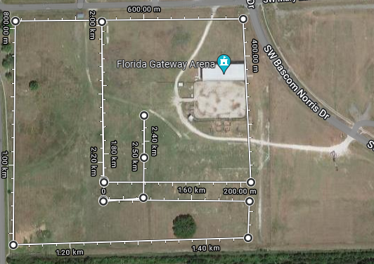
Tiger Run Course Map
Hospitality tent/Packet Pick up
Gate Entrance/ Ticket Check
Spectator Parking
Bus Parking
Team Tent Area
Timer
Finish Line
Start Line

