Panther Prowl XC Classic
College/University Division

Dear Coach,
We would like to extend a cordial invitation to you and your team to the 2026 Panther Prowl Cross Country Classic at Yellow Creek Park just outside of Owensboro, Kentucky.

Our College/University portion of the meet will be contested on Friday evening, September 4th and will be followed by our Middle School and High School races on Saturday morning, September 5th.

College/University Race Schedule – All races Central Standard Time
Friday, September 4, 2026
4:40 pm – Prayer & National Anthem
5:00 pm – Women’s 5000 Meters
5:40 pm – Men’s 8000 Meters
6:25 pm – Awards – Top 2 teams & top 15 individuals in each race

About the Course
Our course at beautiful Yellow Creek Park is conveniently laid out for easy access to kilometer and mile splits and is very spectator friendly. The course is slightly rolling with good footing and extremely well groomed with the reputation of being one of the premier courses in Kentucky.

Specific information concerning the entry process, awards, course maps, and other meet specifics follow. We hope you will join us in what should be a great weekend of running in the Fall.

God bless you and feel free to contact us by phone, text or email.

Emery Crume: Phone: 270 230-6520 Email: emery.crume@daviess.kyschools.us
Tony Rowe: Phone: 270 993-3510 Email: tonyrowe7@yahoo.com

Entry Process
Enter through Direct Athletics (www.directathletics.com.) The entry fee is $125.00 per gender. Teams may have unlimited entries. For individuals without full teams the fee is $20.00 per runner. Entries will close at midnight (central time) on Tuesday, September 1st. Checks should be made payable to Daviess County Middle School and may be brought to the meet or sent ahead of time to:

Emery Crume
Cross-Country Coach
Daviess County Middle School
3901 Fairview Drive
Owensboro, KY 42303

Awards
Top 2 teams and top 15 individuals in each race

Spectator entry fee - $5 per car

Directions to Yellow Creek Park
From the north into downtown Owensboro – after crossing the Cary Glover (US 231) Bridge into Owensboro - go straight (south) two blocks to Fourth Street. Take a left (east) onto Fourth Street/ Hwy 144. Take 144 about 5 miles to Thruston, Ky. The entrance to Yellow Creek Park will be on the right side of the road.

From the northeast – crossing into Kentucky over the William H Natcher Bridge on Highway 231 S near Rockport, Indiana – continue on following Highway 60 W/231 S toward Owensboro. Exit east on Ky 144 (exit 21) and follow it about 2 miles to Thruston, Ky. The entrance to Yellow Creek Park will be on the right side of the road.

From the east (Audubon Parkway) – exit right (east) onto Highway 60 bypass and follow to it around Owensboro to the Ky 144 (exit 21). Turn right and follow 144 about 2 miles to Thruston, Ky. The entrance to Yellow Creek Park will be on the right side of the road.

From the south (William H Natcher Parkway) – exit (east) in the right lane onto the Highway 60 bypass and follow to it to Ky 144 (exit 21) – Turn right and follow 144 about 2 miles to Thruston, Ky. The entrance to Yellow Creek Park will be on the right side of the road.

Recommended Hotels in Owensboro
Hampton Inn & Suites Downtown/Waterfront (270) 685-2005
Holiday Inn / Owensboro Riverfront (270) 683-1111
Hampton Inn South (270) 926-2006
Best Western (270) 689-0939
Fairfield Inn Owensboro (270) 688-8887
Comfort Suites (270) 926-7675
Super 8 Motel (270) 685-3388
Ramada Inn (270) 685-3941
Wingfield Inn & Suites (270) 685-2433
Courtyard by Marriott (270) 685-4140
Towne Place Suites (270) 231-822
Sleep Inn (270) 691-6200

Adrian DeCaussin XC Trail
Yellow Creek Park
Course Records: Women’s 5k – Anna Shields – Point Park 17:42
Men’s 8k - Jason Bowers – Cumberland (TN) 24:07
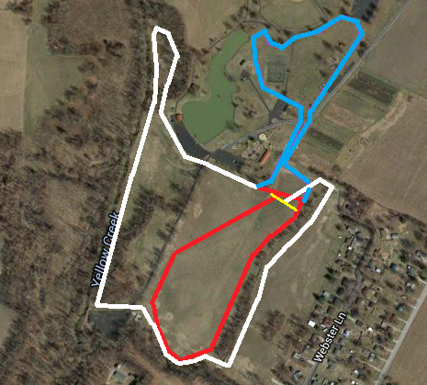
Inner loop (1k) is red
Upper loop (1k) is blue
Outer loop (2k) is white
Start/finish line is yellow

2k = outer loop
3k = inner and outer
5k = inner and two outer loops
8k = inner, upper, and outer loops and repeat

**Mile and kilometer splits are marked by permanent signs on the course for each race distance

