NINTH ANNUAL HARDEE WILDCAT INVITATIONAL
Tuesday, October 8th, 2024

Location: Pioneer Park, Zolfo Springs, FL

Meet Records:
Boys: Antonio Gomez, FHS (2017) 16:22
Girls: Emily Vargas, APHS (2019) 20:08
JH 3K Boys: Frankie Flora (2023) 10:27
JH 3K Girls: Adrianna Mier, HJHS (2017) 11:52

Course Records:
Boys: 15:28 Paul Stafford, LWHS, 2A District 9 meet (2017)
Girls: 19:16 Emily Vargas, APHS, 2A District 9 meet (2018)

Course Details: The course is nearly all grass, with a small amount of paved road surface. It’s a great course for fans and coaches to observe the races. See maps on the next page. The 1 mile and 2 mile are marked and fairly close to the start and finish area. It is a good spikes course. SEE ATTACHED MAPS.

Parking: Buses and cars should park at the large parking lot near the entrance. Parking near the start/finish line causes congestion and reduces viewing by participants.

Schedule (rolling): This year there will be an elementary school race (2K) at 4:15, so please be aware during warmups that these kids will be racing on the course. Races will not overlap unless a varsity runner exceeds 30 minutes. You are encouraged to put slower athletes in the JV division.
- Elementary (2-5) 2K - 4:15
- JH Boys and Girls 3K - 4:45
- Varsity Girls - LIMIT 7
- Varsity Boys - LIMIT 7
- Junior Varsity Combined - unlimited

Entries and Entry Fees:
We will be offering medals to the top 15 in the two varsity races, and a team championship trophy for each varsity race. The top 5 girls and top 5 boys in the Middle School/Junior High division will also receive medals. To offset the costs for these awards, there will be an entry fee per team ($60 per gender/team, or $10 per individual if you have 3 or less on team). This entry covers varsity, JV, and JH/MS entries. Cash or Checks can be brought to the meet or checks can be sent ahead of time to Hardee Senior High School, c/o Coach Rob Beatty, 830 Altman Rd, Wauchula, FL 33873. Make check out to Hardee Cross Country.
All athletes must be entered prior to the meet in order to participate. You do NOT need to specify which athletes are Varsity and JV. All HSentries must be made on Direct Athletics, and MS/JH entries on FLRunners. Entries and timing by elitetiming.net.

If you have any questions, contact me at rdavenport@hardee.k12.fl.us

Thanks, and look forward to seeing you this season

5K HS Course

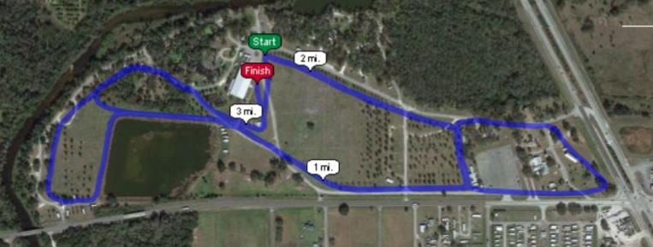

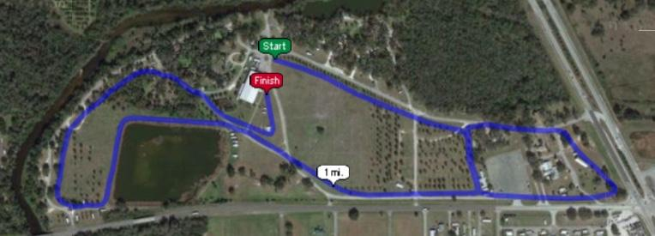
3K Junior High Course

